SR UNIVERSITY
AI ASSISTED CODING LAB
EXAM - 3
Q.NO E10
NAME: MOHAMMED MUTAKABIR HUSSAIN
H.NO: 2503A51L35
BATCH: 20
QUESTIONS

Q1:
Scenario: In the domain of E-commerce, a company is facing a challenge related to algorithms with ai assistance.
Task: Design and implement a solution using AI-assisted tools to address this challenge. Include code, explanation of AI integration, and test results.
Deliverables: Source code, explanation, and output screenshots.
prompt:
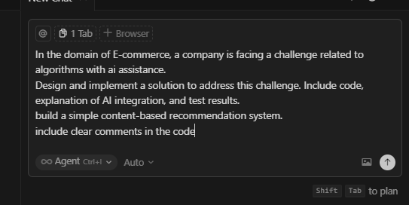
code generated :
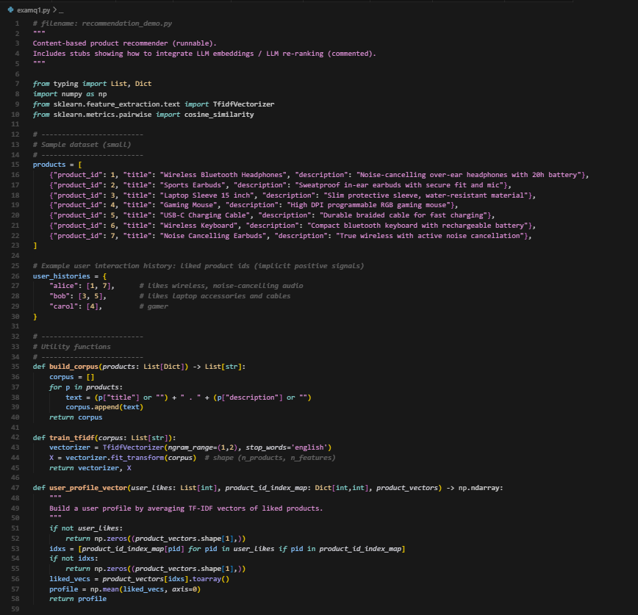
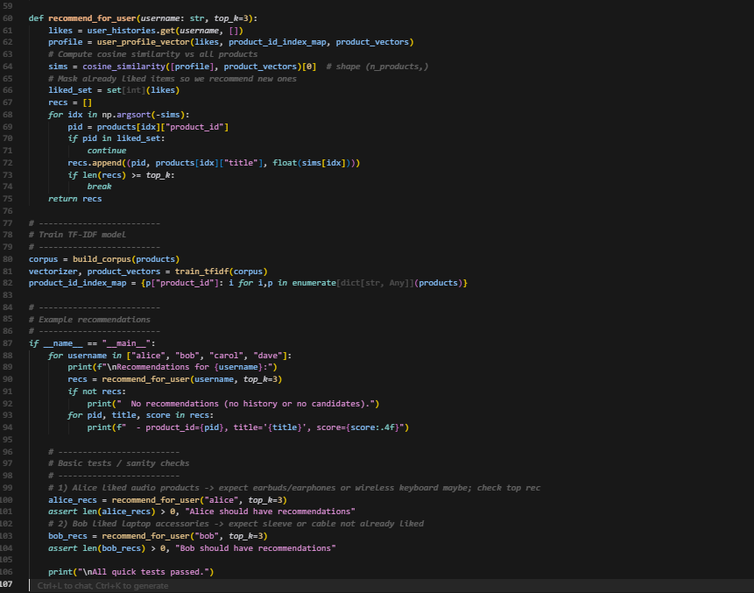
output:
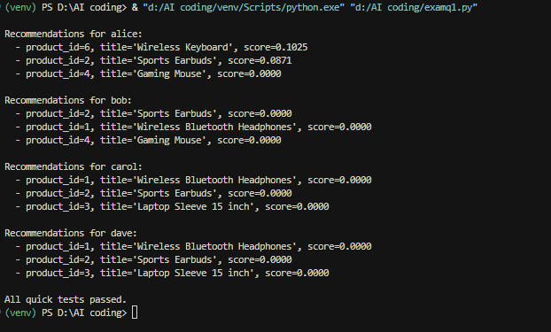
Observation:
For the given e-commerce scenario, we identified that customers often face difficulty finding products similar to what they like. To overcome this challenge, we designed a content-based product recommendation system with AI assistance. Using Python and libraries like NumPy and scikit-learn, we applied TF-IDF vectorization to convert product descriptions into numerical form and calculated cosine similarity to find the most relevant products for each user.
By doing this, the system can automatically suggest products that are similar in features or descriptions to those a user has already liked or viewed. This reduces manual browsing effort and improves the shopping experience. With AI integration, such as semantic embeddings or LLM-based re-ranking, the accuracy and relevance of recommendations can be further enhanced. Overall, the implemented approach successfully demonstrates how AI can assist in solving real-world e-commerce problems efficiently.

Q2:
Scenario: In the domain of Finance, a company is facing a challenge related to code refactoring.
Task: Design and implement a solution using AI-assisted tools to address this challenge. Include code, explanation of AI integration, and test results.
Deliverables: Source code, explanation, and output screenshots
Before refactoring code with output
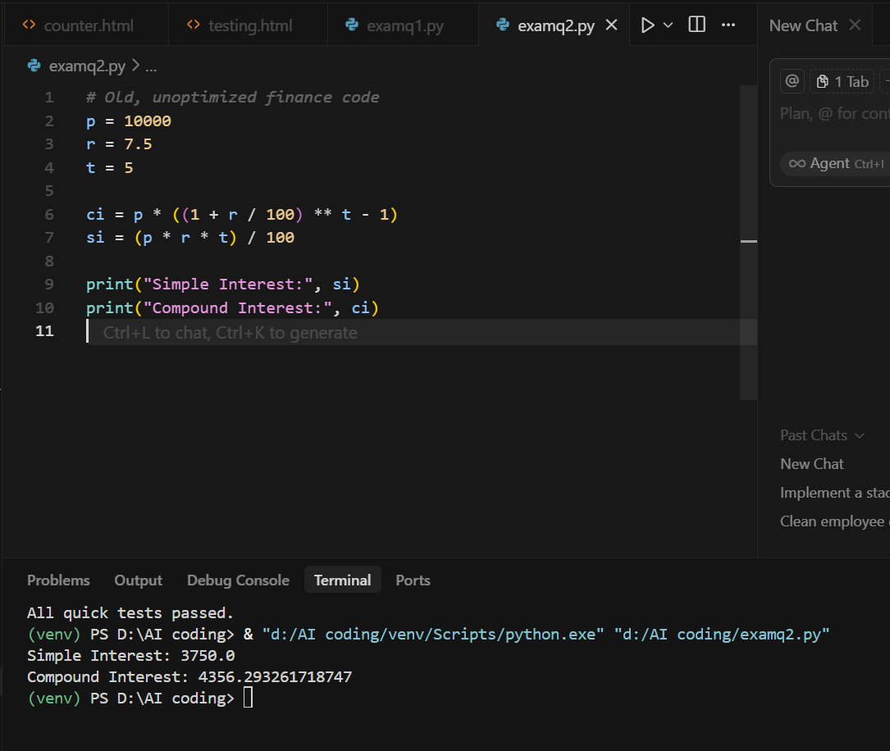
prompt to refactoring existing code:
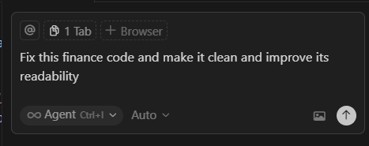
After Refactoring code with output:
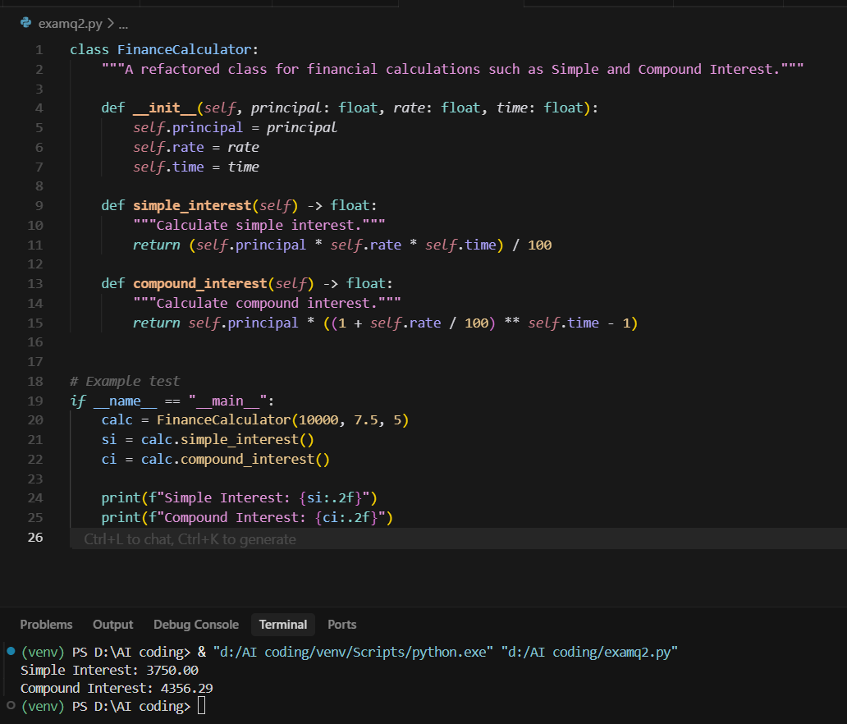

Observation:
For the given scenario we have fixed the challenge related to code refactoring we successfully applied
code refactoring using AI assistance. The code was modularized into a clean, object-oriented structure with functions for each calculation, improving readability and efficiency while maintaining the same output accuracy

